PIZZARIA SQL QUERIES

**KPI’s**

1. **Total Revenue**

SELECT SUM(total_price) AS 'Total Revenue'

FROM pizza_sales

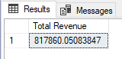

1. **Average Order Value**

SELECT SUM (total_price) /COUNT(DISTINCT order_id) AS 'Average Order Value'

FROM pizza_sales

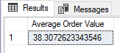

1. **Total Pizza Sold**

SELECT SUM(quantity) AS 'Total Pizza Sold'

FROM pizza_sales

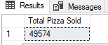

1. **Total Orders Placed**

SELECT COUNT (DISTINCT order_id) AS 'Total Order'

FROM pizza_sales

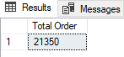

1. **Average Pizza Per Order**

SELECT CAST

(CAST(SUM(quantity) AS DECIMAL (10,2))

/

CAST(COUNT(DISTINCT order_id) AS DECIMAL (10,2)) AS DECIMAL (10,2)) AS 'Avg Pizza Per Order'

FROM pizza_sales

**DAILY TREND FOR TOTAL ORDERS**

SELECT DATENAME(WEEKDAY,order_date) AS 'Order Day',

COUNT(DISTINCT order_id) AS 'Total Orders'

FROM pizza_sales

GROUP BY DATENAME(WEEKDAY,order_date)

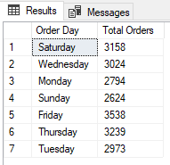

**MONTHLY TREND FOR TOTAL ORDER**

SELECT DATENAME(MONTH, order_date) AS 'Order Month',

COUNT(DISTINCT order_id) AS 'Total Orders'

FROM pizza_sales

GROUP BY DATENAME(MONTH, order_date)

ORDER BY 'Total Orders' DESC

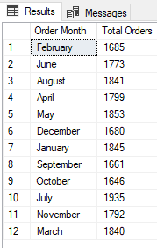

**PERCENTAGE SALES BY PIZZA CATEGORY**

SELECT pizza_category, SUM(total_price)

*

100

/

(SELECT SUM(total_price) FROM pizza_sales) AS '%TotalSalesByCategory'

FROM pizza_sales

GROUP BY pizza_category

**PERCENTAGE SALES BY PIZZA SIZE**

SELECT pizza_size, CAST(SUM(total_price)

*

100

/

(SELECT SUM(total_price) FROM pizza_sales) AS decimal (10,2)) AS '%TotalSalesBySize'

FROM pizza_sales

GROUP BY pizza_size

ORDER BY '%TotalSalesBySize' DESC

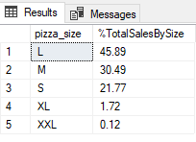

**TOP & BOTTOM 5 BEST SELLERS BY REVENUE, TOTAL QUANTITY AND TOTAL ORDERS**

**BY Revenue**: SELECT TOP 5 pizza_name, SUM(total_price) AS Total_Revenue

FROM pizza_sales

GROUP BY pizza_name

ORDER BY Total_Revenue DESC

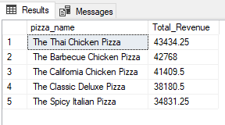

**Bottom 5 by Revenue:** SELECT TOP 5 pizza_name, SUM(total_price) AS Total_Revenue

FROM pizza_sales

GROUP BY pizza_name

ORDER BY Total_Revenue

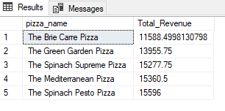

**TOP 5 by QUANTITY**: SELECT TOP 5 pizza_name, SUM(quantity) AS Total_Quantity

FROM pizza_sales

GROUP BY pizza_name

ORDER BY Total_Quantity DESC

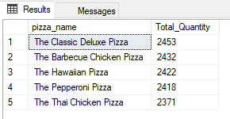

**Bottom 5 by Quantity**: SELECT TOP 5 pizza_name, SUM(quantity) AS Total_Quantity

FROM pizza_sales

GROUP BY pizza_name

ORDER BY Total_Quantity

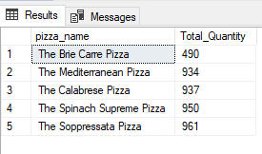

**Top 5 BY ORDER**: SELECT TOP 5 pizza_name, COUNT(DISTINCT order_id) AS Total_Orders

FROM pizza_sales

GROUP BY pizza_name

ORDER BY Total_Orders DESC

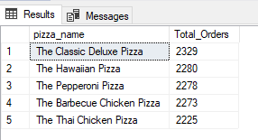

**Bottom 5 BY ORDER**: SELECT TOP 5 pizza_name, COUNT(DISTINCT order_id) AS Total_Orders

FROM pizza_sales

GROUP BY pizza_name

ORDER BY Total_Orders

